**Question 1:**

**Solution:**

**Output:**

**Explanation:**

In this solution, we have initially declared a list named ages with the specific values and sorted the list “ages” using the sort () function.

The Minimum element in the list is shown by using the function min(list) and the maximum element is shown by using the function max(list) and appended the minimum and the maximum values to the sorted list.

The length of the list was found using the length function which determines the capacity of the list.

The range of the list is shown by making difference between last and first element in the list.

Range = ages[len(ages)-1]-ages[0])

**Question 2:**

**Solution:**

**Output:**

**Explanation:**

In this solution a dictionary named Dog has been declared.

dog = {“name" : "Tommy" , "color" : "black", "breed" : "pumalian" , "legs" : 4, "age" : 10}

and the keys and values of the dictionary has been printed.

Then a dictionary named student has been declared which includes the fields such as first name, last name, age, marital status, skills, country, and address. The length of student dictonary is found using the function len().

* len(student))

The values of skills are printed using the student[“skills”] and the data type of skills has been found using the type() function.

* print("Skills : ",student["skills"],"and Data type of skills : ",type(student["skills"]))

The Skills list is modified by appending the skill #JavaScript to the list.

* student["skills"].append("JavaScript")

The Student keys are printed using student.keys().

* print("Student keys are : ",student.keys())

The values of the student dictionary are displayed using student.values().

* print("Student values are : ",student.values())

**Question 3:  
  
Solution:**

**Output:**

**Explanation:**

In this problem the tuples named brothers and sisters are declared which consists of the names of brothers and sisters.

Both the tuples’ brothers and sisters and appended using the concatenation operator “+” and assigned to a new tuple named siblings.

The length of the tuple siblings is found using the function len() (len(siblings)).

Later the tuple is modified by adding the father’s name and mother name.

The names have been appended using the append () function.

**Question 4:**

**Solution:**

**Output:**

**Explanation:**  
A set named it_companies declared below

it_companies = {'Facebook', 'Google', 'Microsoft', 'Apple', 'IBM', 'Oracle', 'Amazon'}

Length of the set is found using the len() function.

print("Length : ",len(it_companies))

New Items are added to the Set using the add() function.

it_companies.add("Twitter")

Later a new Set has been declared

it_companies_2 = { 'Virtusa', 'JPMC' }

The old set (it_companies) is updated with new set (it_companies_2) using update function

it_companies.update(it_companies_2)

An Item can be removed from the Set using the remove function. Virtusa is removed from the set.

it_companies.remove("Virtusa")

Difference between remove () and discard is as follows

The Remove() and Discard() method used to delete the item in the set. The

main difference between remove() and discard() is remove() will raise an

issue if the element is not available in the set but discard element does not

raise an error if so.

Set A and Set B is declared as below

A = {19, 22, 24, 20, 25, 26}

B = {19, 22, 20, 25, 26, 24, 28, 27}

Two sets are joined using the union function. The elements in both sets are assigned to another set below. Common elements are assigned only once after the union elements

C=A.union(B)

Intersection between two sets can be found using the intersection () function. Only common elements are assigned after the intersection operation.

I = A.intersection(B)

The issubset() function is used to determine whether a function is subset or not. This Function gives the true or false as return values.   
S = A.issubset(B)

The isdisjoint () function is used to determine whether a function is disjoint or not. This Function gives the true or false as return values.

D = A.isdisjoint(B)

union is used to join the two sets.

print("Joining A with B : ",A.union(B))

print("Joining B with A : ",B.union(A))

Symmetric_difference() is used to check the symmetric difference between two function. This method returns all the methods in the set except the intersection elements.

Sy = A.symmetric_difference(B)

Clear method is used to delete the elements in the Set. It removes all the elements in the Set.

A.clear()

B.clear()

The Age Set is declared as below

age = [22, 19, 24, 25, 26, 24, 25, 24]

Typecasting is a method of converting object of one type to another type. Here the list is converted into the age

sage = set(age)

The length of list before converting and length after converting is shown using the len() function.

print("length of set age : ",len(sage))

print("length of list age : ",len(age))

**Question 5:  
Solution:**

**Output:**

**Explanation:**  
Initially the radius of the circle is initialized as 30 meters.  
The area of the circle is determined by formula 3.14*(radius**2).

_area_of_circle_ = 3.14 * (r**2)

#Finding The Circumference of the circle is determined by the formula 2*3.14*radius.

_circum_of_circle_ = 2 * 3.14 * r  
  
Now the radius of the circle is determined by the input given by the user.

The input radius is given the type int.

input_radius = int(input("Enter the radius "))

And the area of the circle is calculated.

area = 3.14 * input_radius

**Question 6:**  
**Solution:**

**Output:**

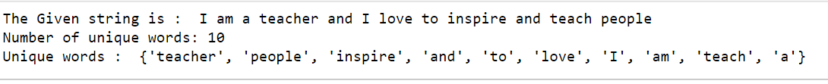

**Explanation:**  
  
A string named str is declared as below:

str = "I am a teacher and I love to inspire and teach people"

Now the String is Stored in a set using the split() function.

Set = set(str.split(" "))

A set does not allow the duplicate elements. Hence when the string is stored in a set only the unique words will be present in that set.

Now, the number of unique words in the string can be found using the len() function on set:

print ("Number of unique words:", len(Set))

The unique words can be displayed by printing the set.

print ("Unique words: ", Set)

**Question 7:  
  
Solution:**



**Output:**

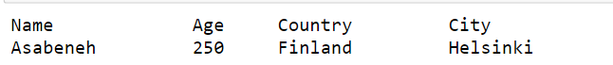

**Explanation:**  
  
The given pattern has been printed using the escape tab sequence “\t” and the second line is displayed using a new print function.

**Question 8:**

**Solution:**

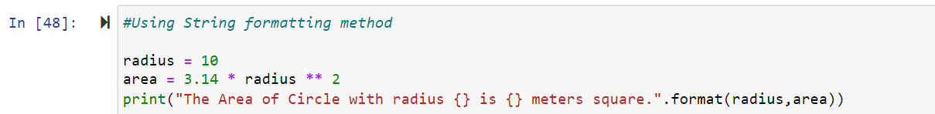

**Output:**



**Explanation:**  
The radius of the circle is declared as 10 meters and the area of the circle is calculated by using the formula 3.14 * (r**2). Now the area is formatted using the strung format() function.

The format() method formats the specified value(s) and insert them inside the string's placeholder.

**Question 9:  
  
Solution:**

**Output:**

**Explanation:**  
In this problem an empty list named l which reads the weights of N students is declared

l = []

The number of students is taken from the users as below:

n = int(input("Enter number of weights : "))

and the values are appended to the list as below:

“”for i in range(0, n):

ele = int(input())

l.append(ele) # adding the element”"

A list named Kg is declared which contains the values converted from lbs to Kilograms

kg=[]

1 lb = 0.45359237 kg.   
This value is used for the converting lbs to kilograms as below:

for i in range(0, n):

ele =0.45359237 * i

kg.append(ele)

Question 10:

Solution:

**GitHub link:**  
  
<https://github.com/AldenaHaneesha/MachineLearning---Assignment-1>